Using AutoHotKey v2
for updating the
FrSky Suite screenshots

Table of Contents
Overview 4
Preparation 4
Localizing the forge 8
Localizing the screenshot macros 9
Updating Ethos screenshots 9
Background 13

Overview
This document describes how to use AutoHotKey v2 to update the ethos-manual FrSky Suite screenshots.

To update the screenshots we work inside a local folder of your choice. Once updated, the screenshots must be copied to your ethos-manual/<language>/assets folder and updated the normal way with a GitHub Desktop Pull, Commit and Push sequence.

Preparation

Configure your PC screen
1. Change your screen size to 1920 x 1080 which is the Windows HD size. Right-click in an open area on your desktop, and select ‘Display Settings.

Suite assumes 1920 x 1080 as the normal Windows screen size. If you screen size is different, Suite uses the Windows Scale factor to adjust to the bigger screen size. For consistency we will ask everyone to use this default size so that the x/y values for AutoHotkey simulated mouse clicks will target the correct location on the screen.

FrSky Suite Demo version

Installation
1. Download the FrSky Suite Demo version ‘FrSky-Suite-Windows-2.0.2-DEMO1.exe’ that @Nicholas Luo uploaded to the #manual group on Discord on 29 September 2026.

2. Install the FrSky Suite Demo version.

Configure the mock radio
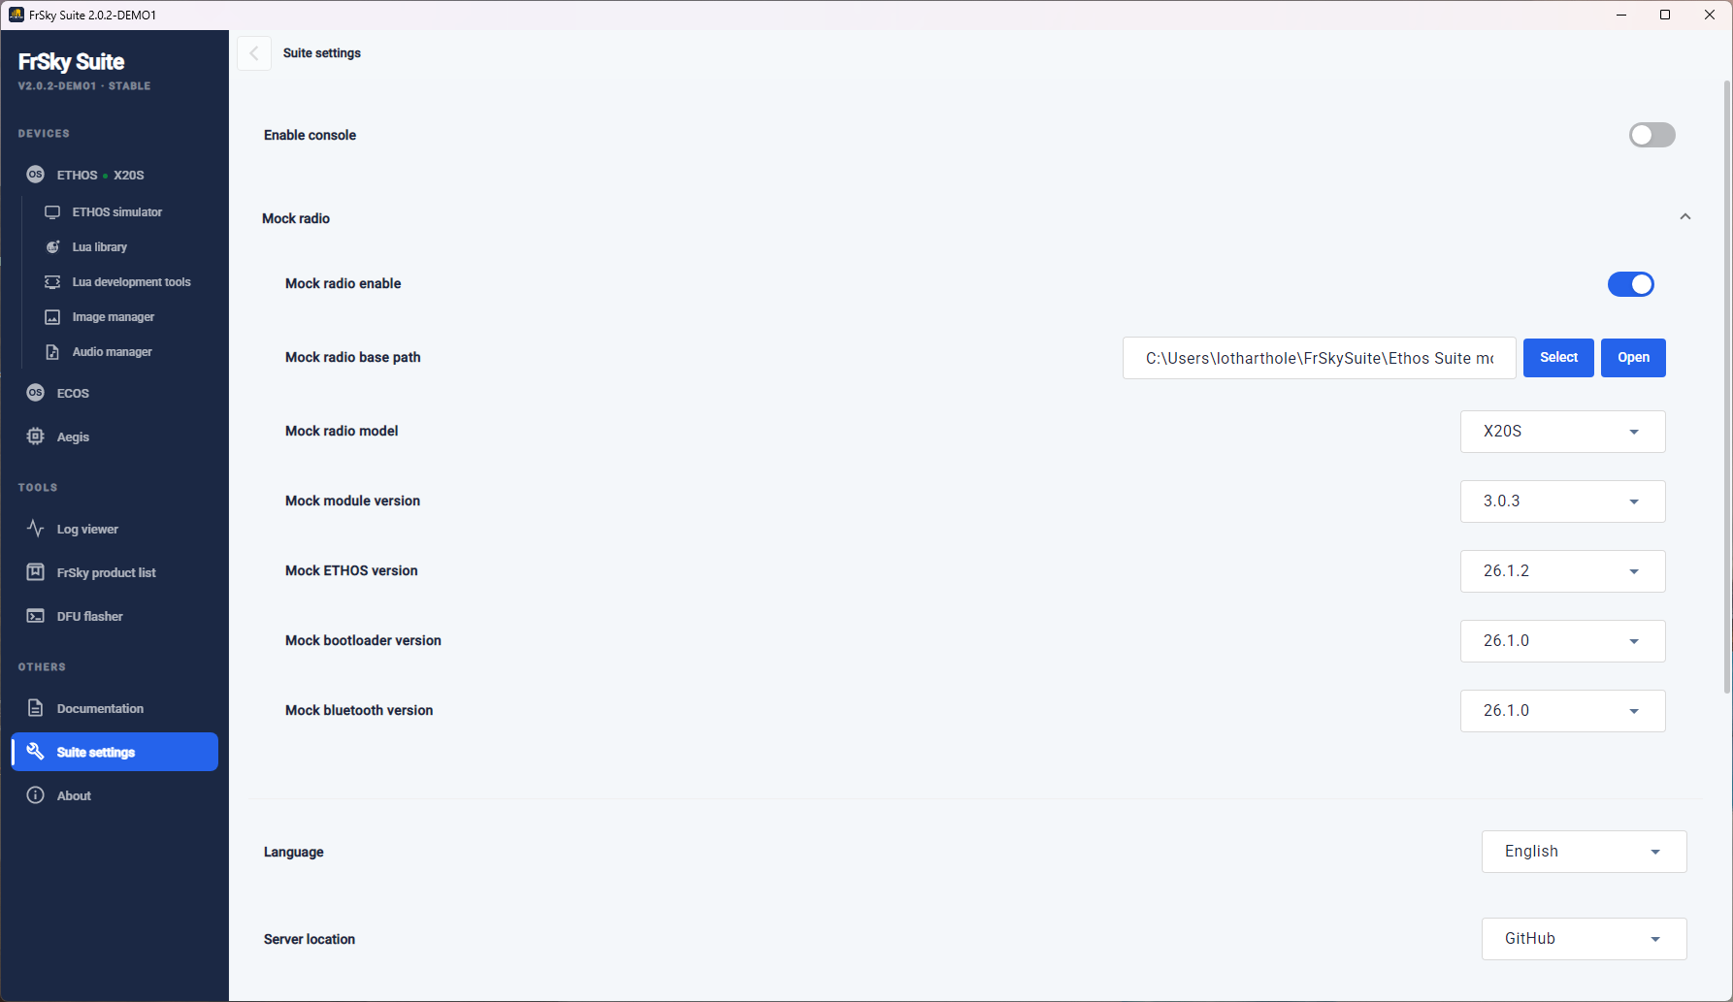

1. Create a folder in your user area called FrSkySuite.

2. Create another folder inside FrSkySuite\Ethos Suite mock radio.

3. Into the Ethos Suite mock radio folder copy the following from ethos-manual\forge:
\models
\documents
\bitmaps
\scripts

4. Go to Suite Settings.

5. Set the ‘Mock radio base path’ to the ‘ FrSkySuite\Ethos Suite mock radio’ folder you created in 3b above.

6. Click on ‘Open’ and check that you can see the folder.

7. Once the mock radio path has been configured, enable the mock radio.

8. Switch to Devices / Ethos and check that it shows a radio connected. If not, you may have to disable and re-enable the mock radio. Only proceed once Devices / Ethos Suite shows a radio connected.

9. Go back to Suite Settings and set the other mock radio settings (i.e. version numbers) as shown above.

Configure the Suite ‘Backup location’
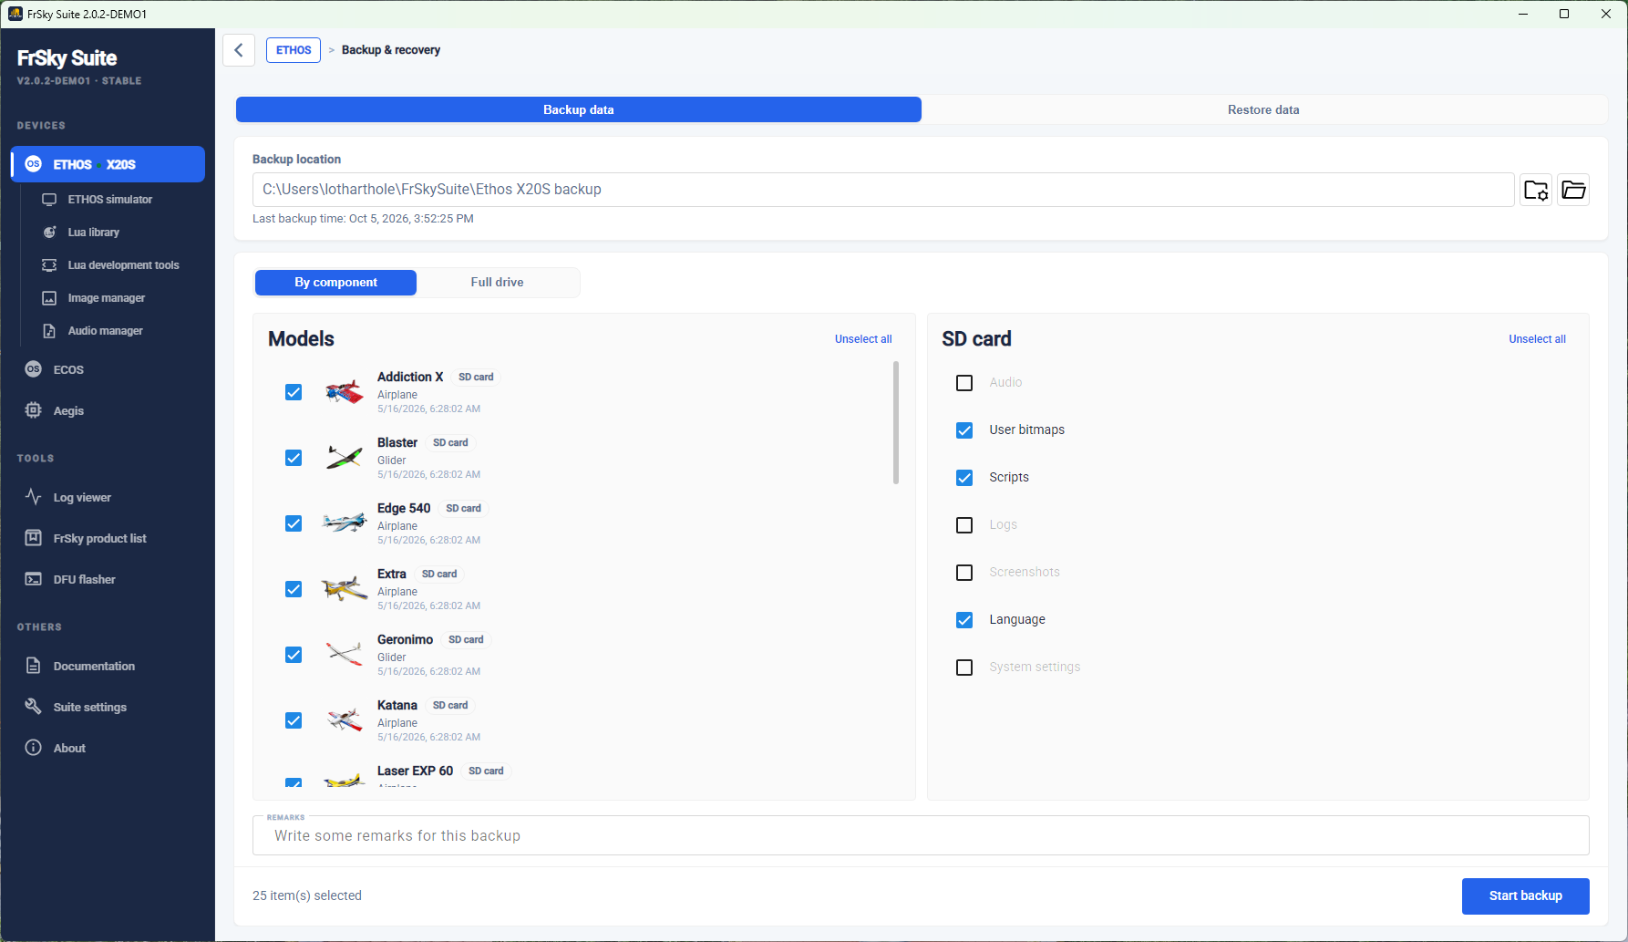

1. With the mock radio enabled, create a folder C:\Users\……...\FrSkySuite\Ethos X20S backup.

2. Go to Devices / Ethos / Backup & Recovery.

3. Configure the ‘Backup location’ to point to C:\Users\……...\FrSkySuite\Ethos X20S backup. Having a specific backup location for use with the mock radio to create screenshots for the manual means that this folder is separate and will not interfere with your normal use of Suite for your actual radio and models.

AutoHotKey v2
1. Download AutoHotKey v2. Go to https://www.autohotkey.com/v2/ and click on the ‘Latest installer’ link.

2. Install AutoHotKey v2.

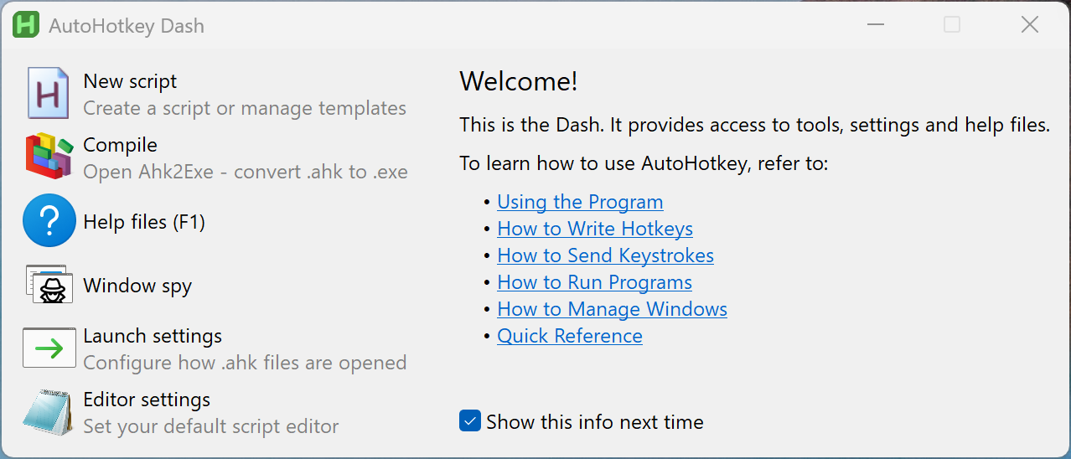

The AutoHotKey dash looks like this.

Click on some of the links to learn more about it.

We will use is to control FrSky Suite and take screenshots.

3. Click on ‘New script’.

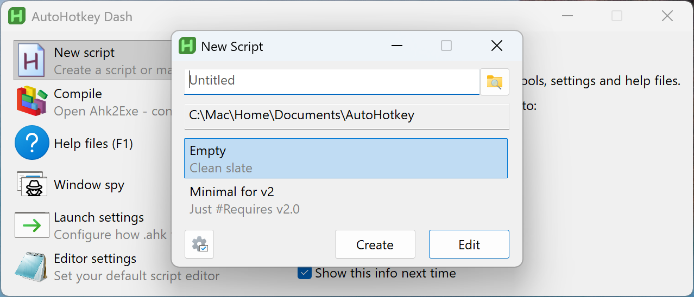

4. Click on Create. AutoHotKey will create an empty script in a new folder. Make a note of the folder location. You will use this location to store our Suite scripts, for example C:\...........\Documents\AutoHotkey.

5. Create a screenshots folder below the ‘AutoHotkey’ folder. This is where AutoHotkey will save the screenshots it creates.

FrSky Suite scripts for AHK2.
1. Download the config.ini configuration file from ethos-manual/english/autohotkey and save it in the local Autohotkey folder created above.

2. Open the config.ini with a code editor like VS Code.

[Paths]
; No quotes are needed around the path, even with spaces
SuitePath=C:\Program Files\FrSky Suite_demo\FrSky Suite.exe
ScreenshotsPath=C:\Users\lotharthole\autohotkey\screenshots

3. Edit SuitePath to point to your demo FrSky Suite app.

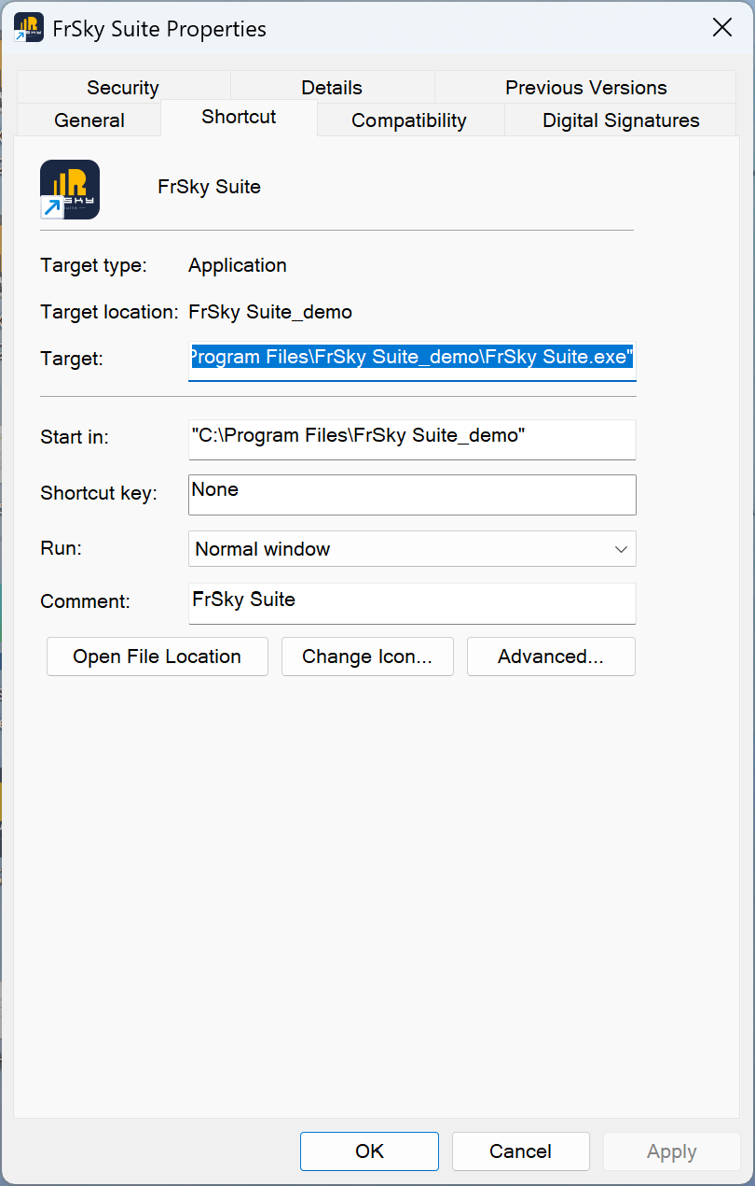

(To find the path to your demo FrSky Suite app, rightclick on the icon on your desktop, select ‘Properties’ and copy the ‘Target’.)

4. Edit ‘ScreenshotsPath’ to point to the screenshots folder you created above.

5. Finally copy the most recent script from ethos-manual/english/autohotkey, eg. FrSuiteMacro_rev4.ahk to your AutoHotkey folder.

Execution
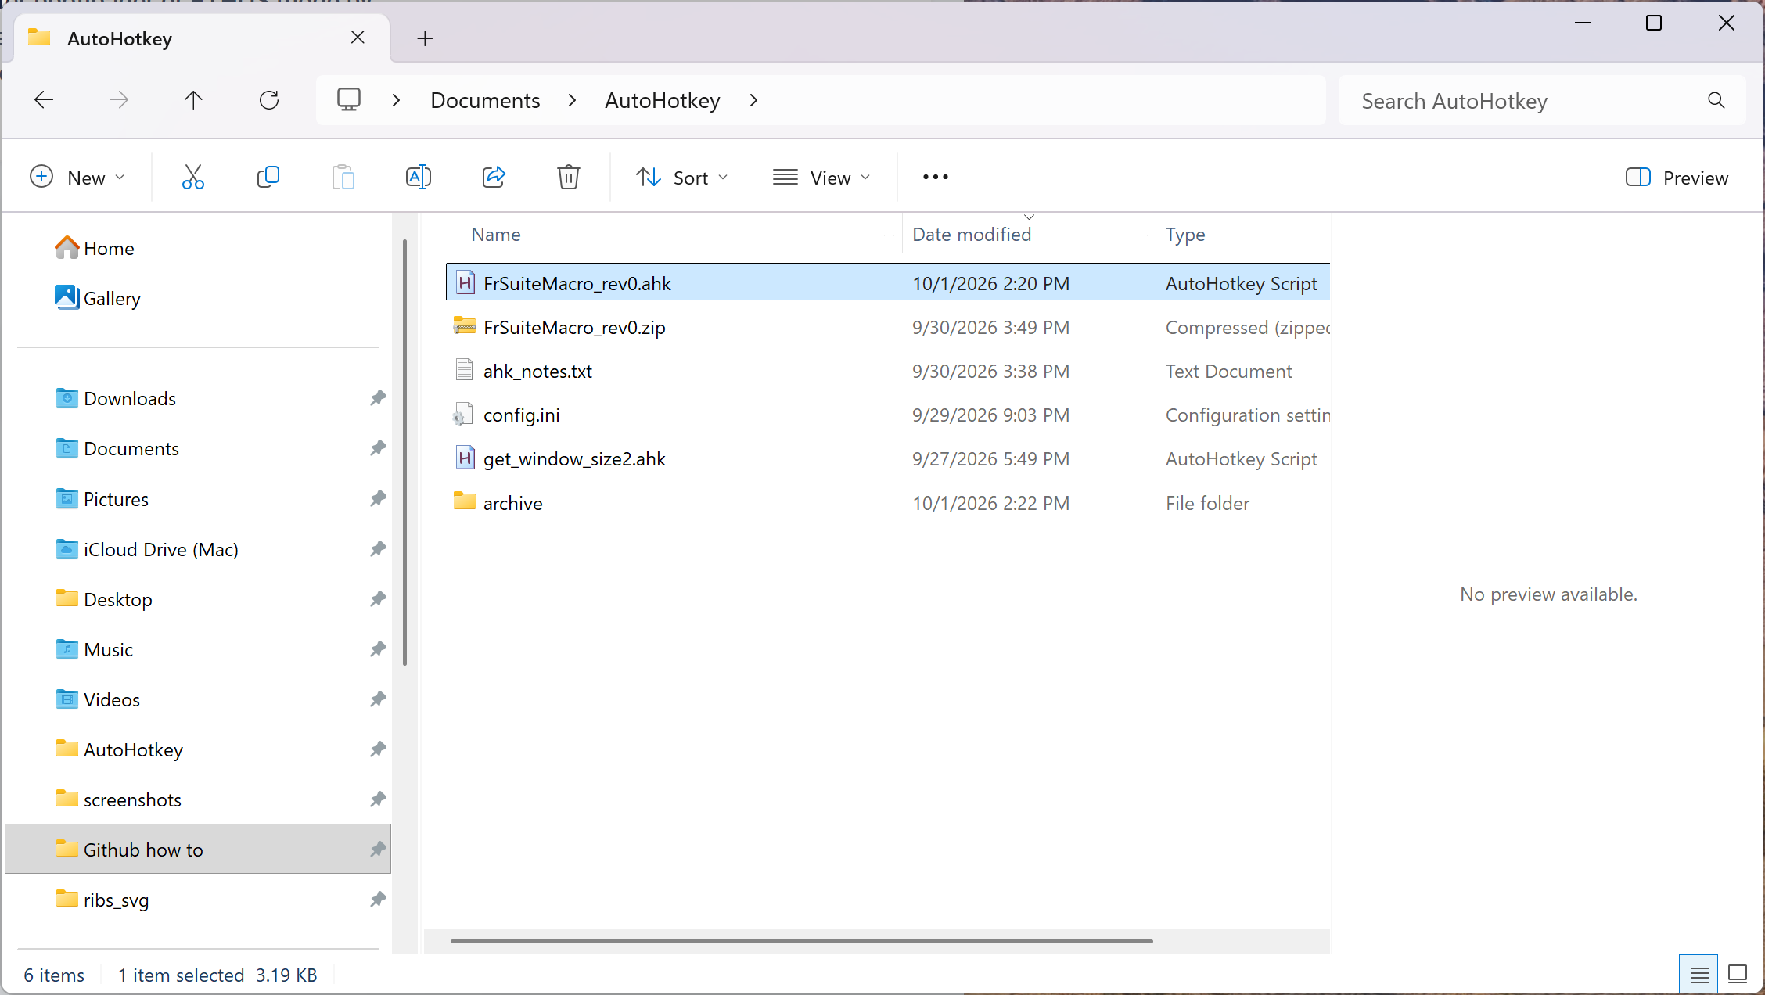

1. Download the FrSuiteMacro_rev2.ahk script file from ethos-manual/english/autohotkey and save it in the local Autohotkey folder created above.

2. Double click on the ‘FrSuiteMacro_rev2.ahk’ script.

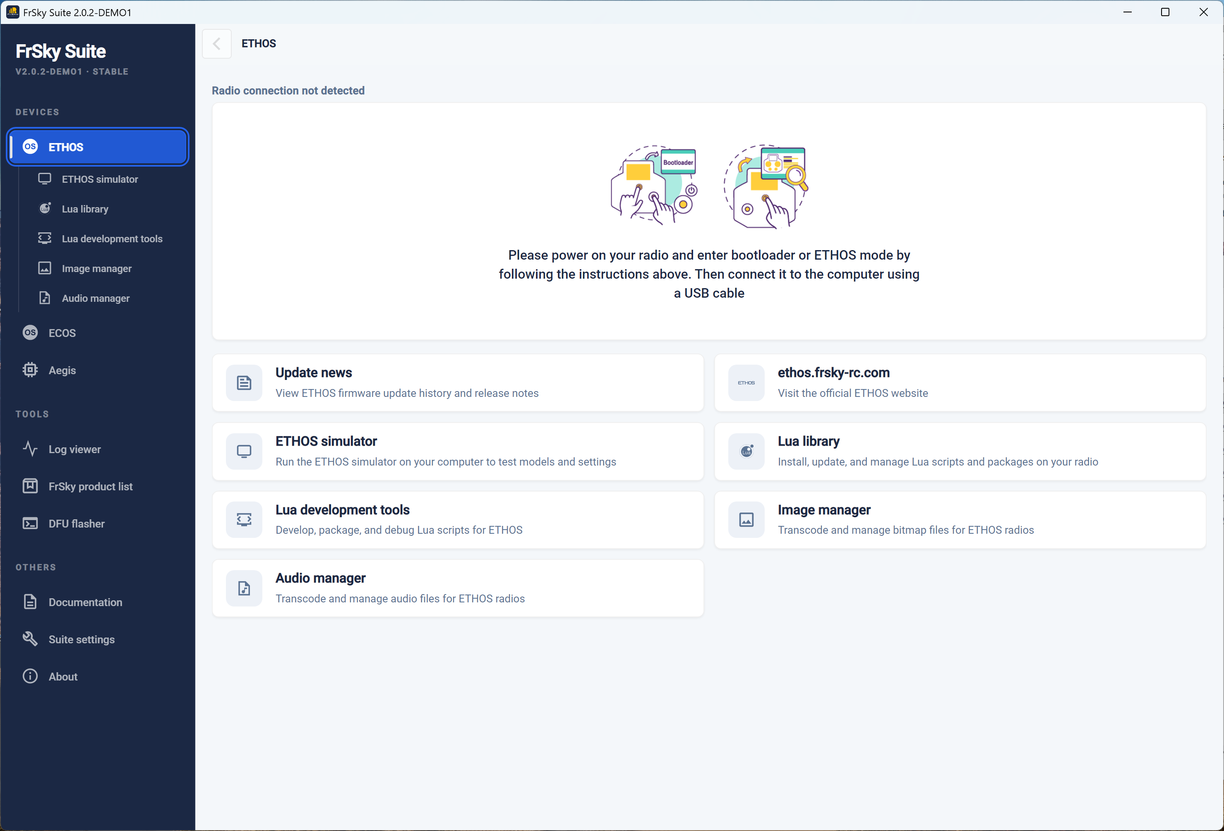

3. FrSky Suite should open, then get resized to a larger size, and a screenshot captured. When completed you should see a ToolTip saying it has saved to your target path followed by a beep.

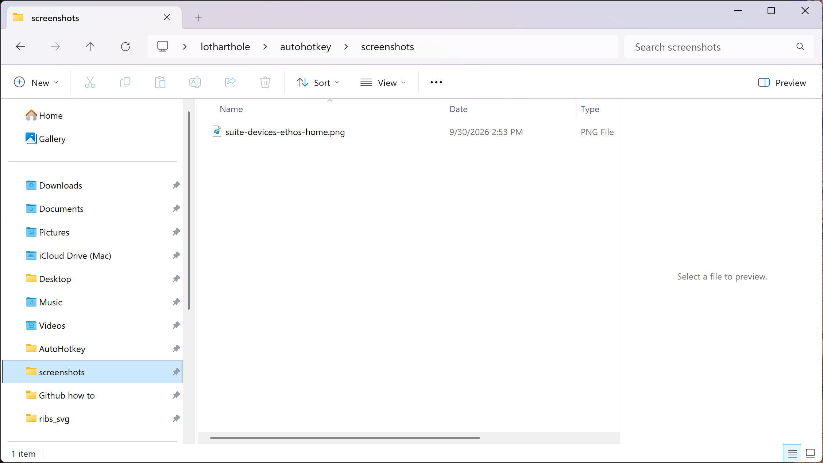

4. Check in the location ‘ScreenshotsPath’ that you defined in the config.ini file.

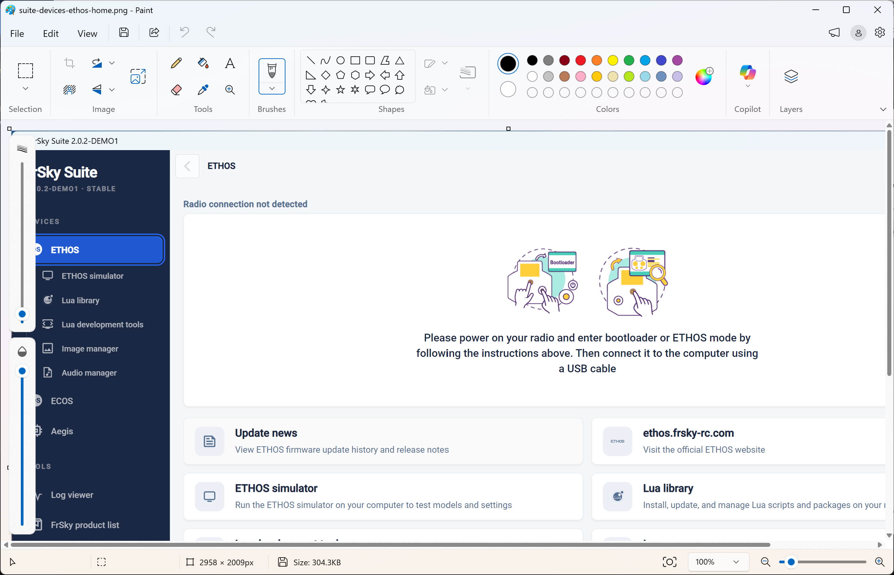

5. Double click on the screenshot. It will probably open in Paint. Check that the image size is 2958 x 2009.

6. Please let me know the result.

